DAY 7- PROGRAMMING

1. Coin Change – Supermarket Billing
Aim:To find the minimum number of coins required to return a balance amount using the Greedy Coin Change algorithm.
Algorithm
- Read the coin denominations and amount.
- Sort the coins in descending order.
- Select the largest coin that does not exceed the remaining amount.
- Subtract the selected coin from the amount.
- Repeat until the amount becomes zero.
- Display the selected coins and minimum number of coins.
Execution:
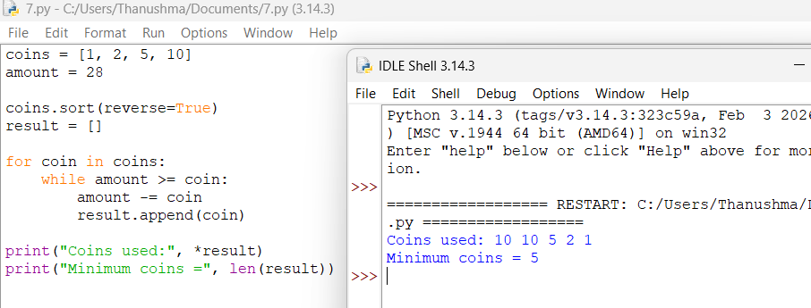
2. Coin Change – Parking Meter
Aim:To determine the minimum number of coins needed to make the given parking fee using the Greedy method.
Algorithm
- Read the denominations and amount.
- Sort denominations in descending order.
- Choose the largest possible coin repeatedly.
- Subtract it from the remaining amount.
- Continue until the amount becomes zero.
- Count and display the coins.
Execution:
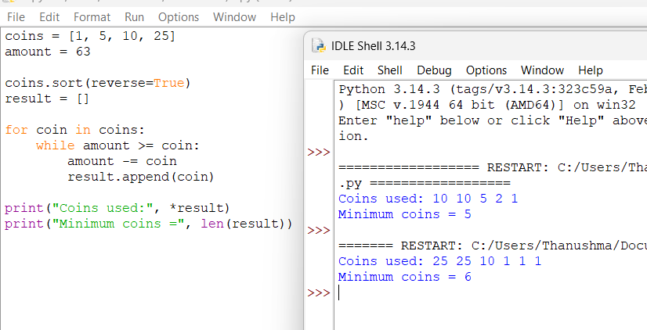

3. Coin Change – Ticket Counter
Aim:To find the minimum number of coins required to return change using available denominations.
Algorithm
- Read coins and amount.
- Sort coins in descending order.
- Select the largest possible coin.
- Subtract it from the amount.
- Repeat until the amount is zero.
- Display the coins and their count.
Execution:
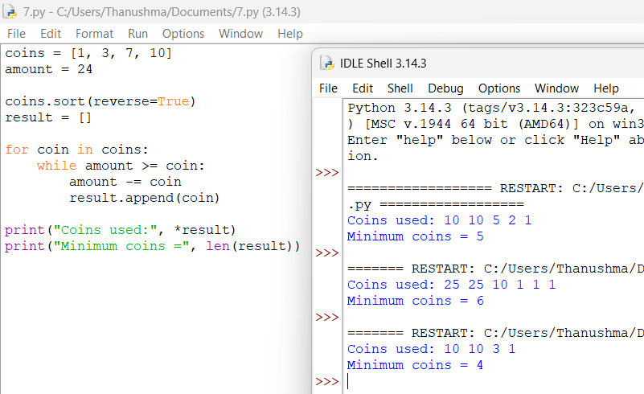

4. Fractional Knapsack – Food Delivery Truck
Aim:To maximize the total profit of food packets that can be carried using the Fractional Knapsack algorithm.
Algorithm
- Calculate profit-to-weight ratio for every item.
- Sort items in decreasing order of ratio.
- Select the complete item if it fits.
- Otherwise, take the required fraction of the item.
- Continue until the capacity becomes zero.
- Display the maximum profit.
Execution:
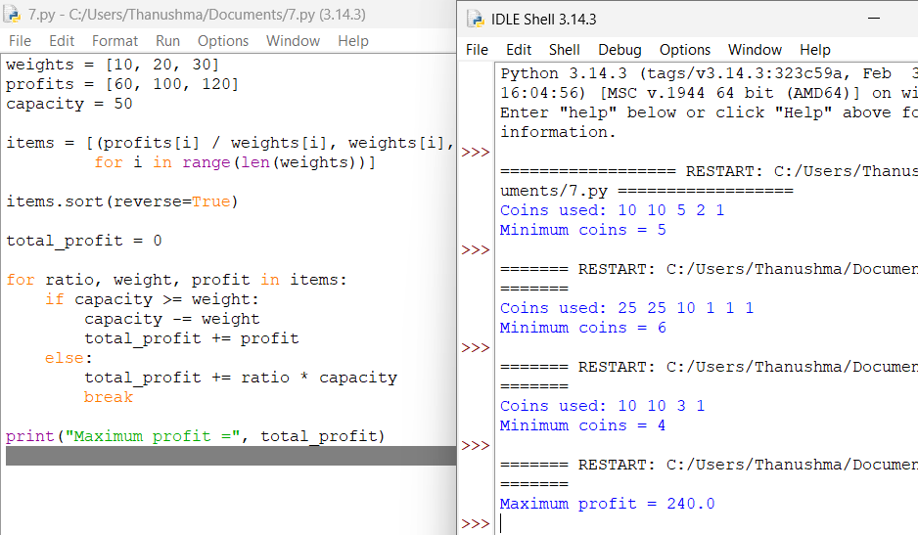

5. Fractional Knapsack – Gold Transport
Aim:To maximize the value of gold transported within the given weight capacity.
Algorithm
- Calculate profit/weight ratio.
- Sort items by decreasing ratio.
- Select the item with the highest ratio first.
- Take complete items while possible.
- Take a fraction of the next item if necessary.
- Calculate the maximum profit.
Execution:
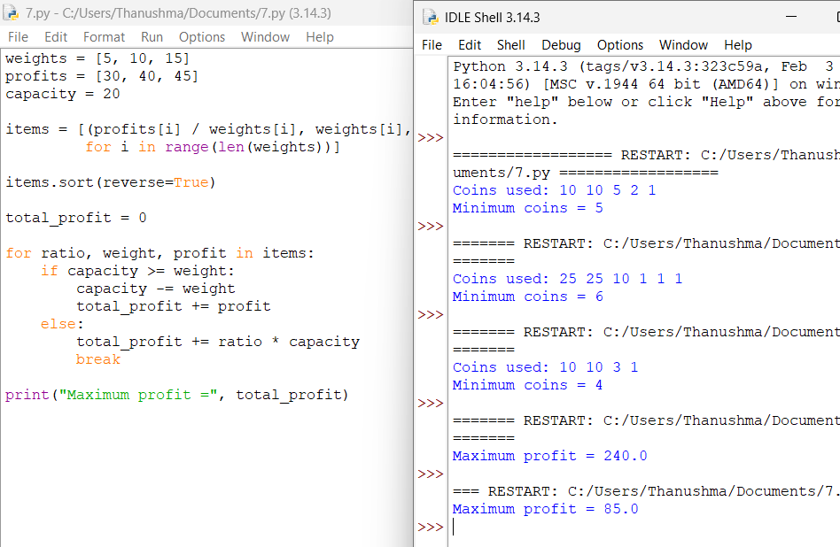

6. Fractional Knapsack – Relief Material Loading
Aim:To maximize the importance value of relief materials loaded within a limited capacity.
Algorithm
- Calculate the profit-to-weight ratio.
- Sort items according to decreasing ratio.
- Select the highest-ratio items first.
- Take complete items whenever possible.
- Take a fraction when the remaining capacity is insufficient.
- Display maximum profit.

Execution:
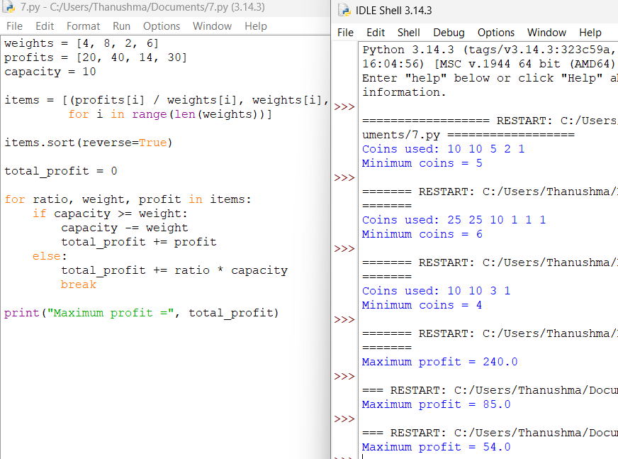
7. Job Sequencing – Software Company Tasks
Aim:To schedule jobs before their deadlines to obtain maximum profit using the Job Sequencing with Deadlines algorithm.
Algorithm
- Store job name, deadline, and profit.
- Sort jobs in decreasing order of profit.
- Create empty time slots.
- For each job, find the latest available slot before its deadline.
- Schedule the job if a slot is available.
- Calculate and display maximum profit.

Execution:
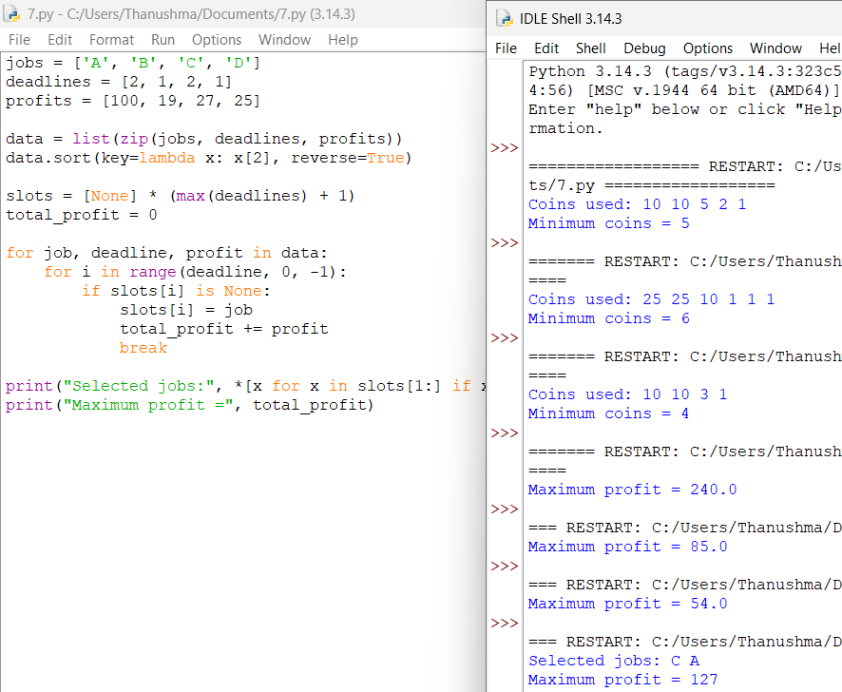

8. Job Sequencing – Exam Paper Evaluation
Aim:To schedule paper evaluation jobs before their deadlines while maximizing the total reward.
Algorithm
- Read jobs, deadlines, and profits.
- Sort jobs by decreasing profit.
- Create available time slots.
- Assign each job to the latest available slot before its deadline.
- Skip a job if no slot is available.
- Display selected jobs and maximum profit.

Execution:
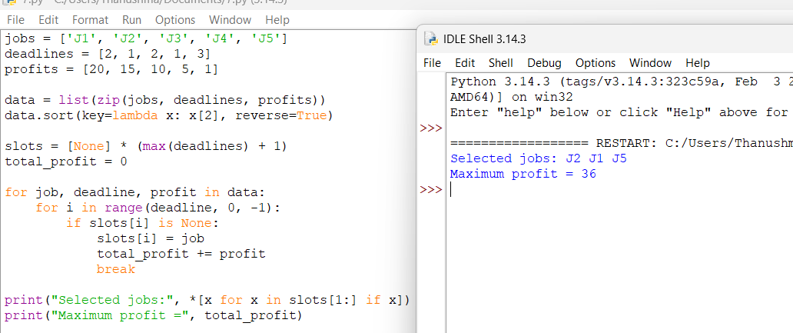

9. Job Sequencing – Printing Press Orders
Aim:To schedule printing orders before their deadlines to maximize total profit.
Algorithm
- Read job details. Sort jobs by decreasing profit.
- Create time slots according to the maximum deadline.
- Place each job in the latest free slot. Calculate the total profit.
- Display selected jobs.
Execution:
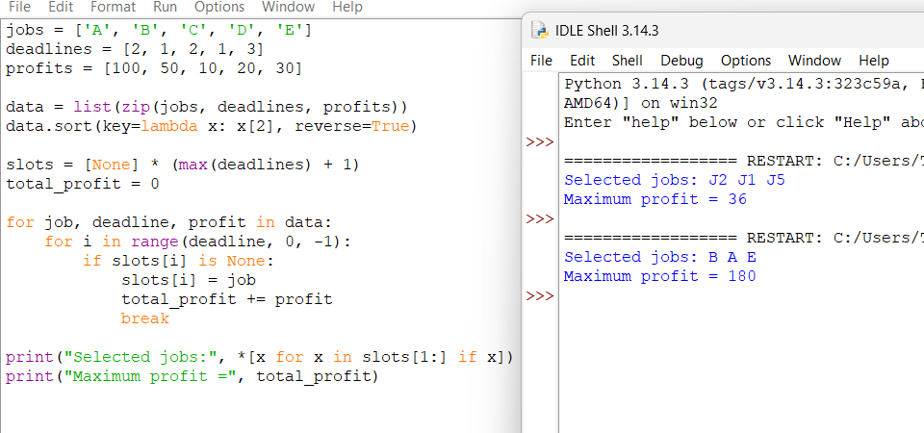
10. Job Sequencing – Freelance Projects
Aim:To schedule freelance projects before deadlines to maximize total income.
Algorithm
- Read project names, deadlines, and profits.
- Sort projects in decreasing order of profit.
- Create available time slots.
- Assign each project to the latest free slot.
- Calculate the total income.
- Display selected projects.
Execution:
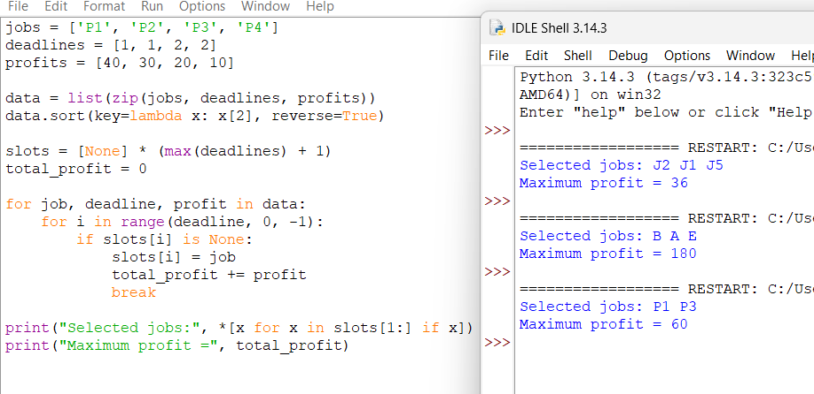

11. Huffman Coding – Text Compression
Aim:To generate Huffman codes for characters based on their frequencies and achieve efficient text compression.
Algorithm
- Create a node for every character.
- Insert all nodes into a min-priority queue.
- Remove the two nodes with the lowest frequencies.
- Create a new node with their combined frequency.
- Insert the new node back into the queue.
- Repeat until one node remains.
- Traverse the Huffman tree and assign 0 to the left branch and 1 to the right branch.
- Display the codes.
Execution:
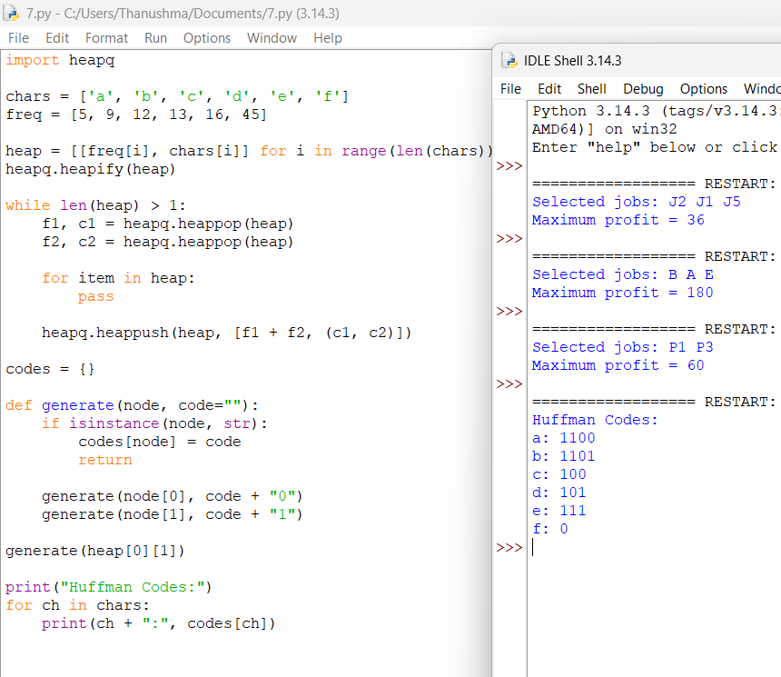

12. Huffman Coding – Message Encoding
Aim:To generate Huffman codes for frequently used message symbols to reduce the number of bits required for encoding.
Algorithm
- Create nodes for all characters.
- Insert nodes into a min-heap.
- Remove the two nodes with minimum frequencies.
- Combine them into a new node.
- Insert the new node into the heap.
- Repeat until one tree remains.
- Traverse the tree and assign binary codes.
- Display Huffman codes.
Execution:
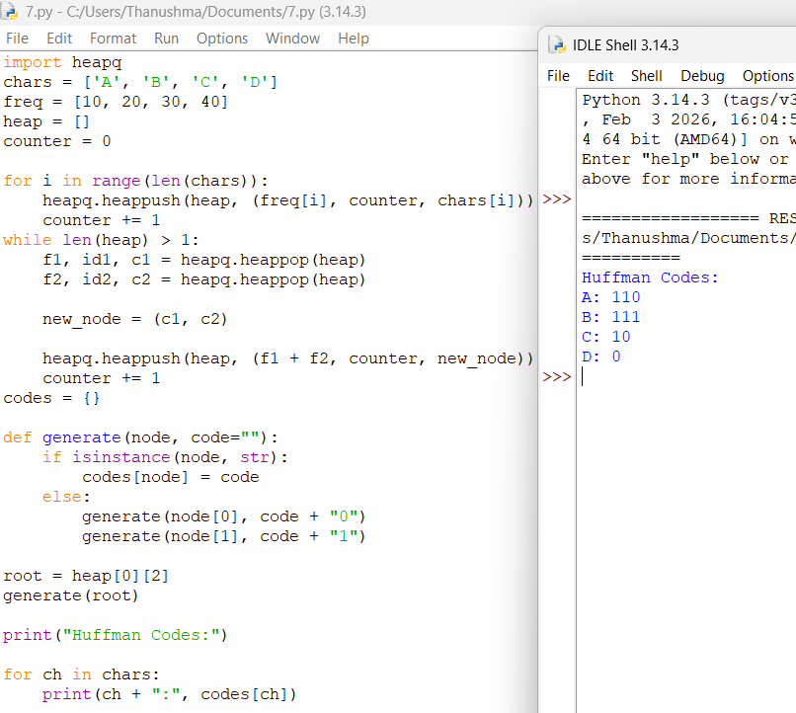

13. Huffman Coding – Sensor Data Compression
Aim:To generate Huffman codes for IoT sensor symbols and minimize the average number of bits required for data transmission.
Algorithm
- Create a node for every sensor symbol.
- Insert all nodes into a min-heap.
- Select the two lowest-frequency nodes.
- Combine their frequencies.
- Insert the combined node back.
- Repeat until one tree remains.
- Traverse the tree to generate binary codes.
- Display the codes.

Execution:
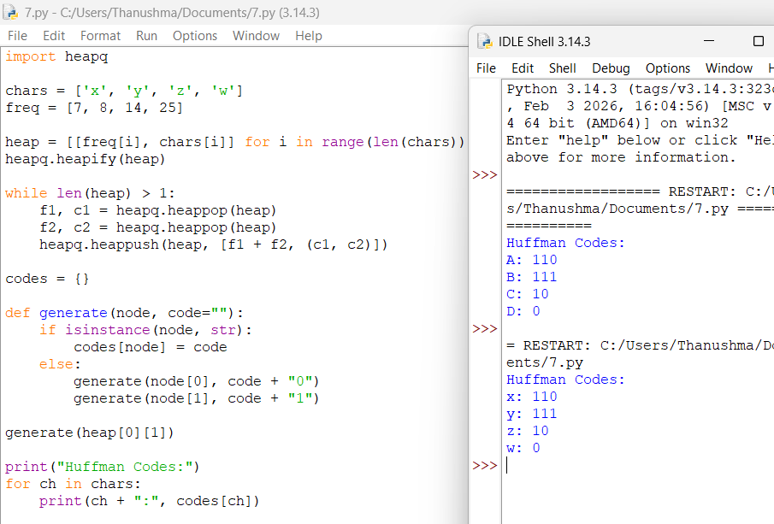

14. Coin Change – Vending Machine
Aim:To find the minimum number of coins required by a vending machine to provide the given change.
Algorithm
- Read the denominations and amount.
- Sort coins in descending order.
- Select the largest possible coin.
- Subtract it from the remaining amount.
- Repeat until the amount becomes zero.
- Display the coins and their count.

Execution:
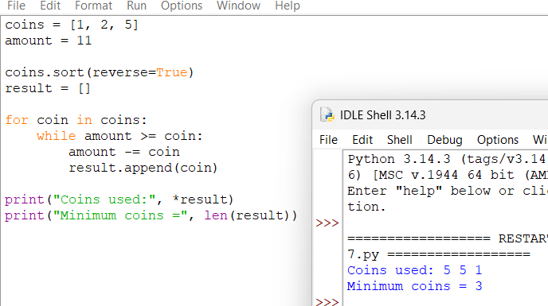

15. Fractional Knapsack – Warehouse Packing
Aim:To maximize the total value of items placed in a warehouse within a limited weight capacity using the Fractional Knapsack algorithm.
Algorithm
- Calculate profit-to-weight ratio for every item.
- Sort items in decreasing order of ratio.
- Select the highest-ratio item first.
- Add complete items while capacity permits.
- Take a fraction of the next item when required.
- Calculate and display the maximum profit.
Execution:
